**COVID-19 and Mental Health**

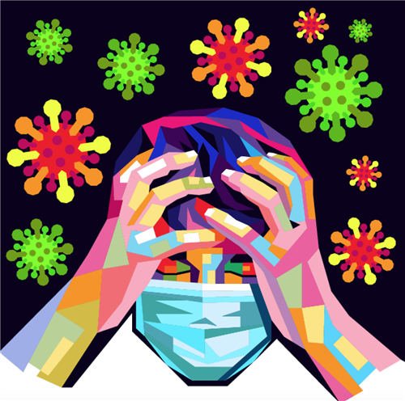

**Worries and anxiety about COVID-19 and its impact can be overwhelming.**

**Social distancing makes it even more challenging.**

**Learn ways to cope during this pandemic.**

The COVID-19 pandemic has likely brought many changes to how you live your life, and with it uncertainty, altered daily routines, financial pressures and social isolation. You may worry about getting sick, how long the pandemic will last and what the future will bring. Information overload, rumors and misinformation can make your life feel out of control and make it unclear what to do.

During the COVID-19 pandemic, you may experience stress, anxiety, fear, sadness and loneliness. And mental health disorders, including anxiety and depression, can worsen.

Learn self-care strategies and get the care you need to help you cope.

**Self-care strategies**

Self-care strategies are good for your mental and physical health and can help you take charge of your life. Take care of your body and your mind and connect with others to benefit your mental health.

**Take care of your body**

Be mindful about your physical health:

* **Get enough sleep.** Go to bed and get up at the same times each day. Stick close to your typical schedule, even if you're staying at home.
* **Participate in regular physical activity.** Regular physical activity and exercise can help reduce anxiety and improve mood. Find an activity that includes movement, such as dance or exercise apps. Get outside in an area that makes it easy to maintain distance from people — as recommended by the U.S. Centers for Disease Control and Prevention (CDC) and the World Health Organization (WHO) or your government — such as a nature trail or your own backyard.
* **Eat healthy.** Choose a well-balanced diet. Avoid loading up on junk food and refined sugar. Limit caffeine as it can aggravate stress and anxiety.
* **Avoid tobacco, alcohol and drugs.** If you smoke tobacco or if you vape, you're already at higher risk of lung disease. Because COVID-19 affects the lungs, your risk increases even more. Using alcohol to try to cope can make matters worse and reduce your coping skills. Avoid taking drugs to cope, unless your doctor prescribed medications for you.
* **Limit screen time.** Turn off electronic devices for some time each day, including 30 minutes before bedtime. Make a conscious effort to spend less time in front of a screen — television, tablet, computer and phone.
* **Relax and recharge.** Set aside time for yourself. Even a few minutes of quiet time can be refreshing and help to quiet your mind and reduce anxiety. Many people benefit from practices such as deep breathing, tai chi, yoga or meditation. Soak in a bubble bath, listen to music, or read or listen to a book — whatever helps you relax. Select a technique that works for you and practice it regularly.

**Take care of your mind**

Reduce stress triggers:

* **Keep your regular routine.** Maintaining a regular schedule is important to your mental health. In addition to sticking to a regular bedtime routine, keep consistent times for meals, bathing and getting dressed, work or study schedules, and exercise. Also set aside time for activities you enjoy. This predictability can make you feel more in control.
* **Limit exposure to news media.** Constant news about COVID-19 from all types of media can heighten fears about the disease. Limit social media that may expose you to rumors and false information. Also limit reading, hearing or watching other news, but keep up to date on national and local recommendations. Look for reliable sources such as the CDC and WHO.
* **Stay busy.** A distraction can get you away from the cycle of negative thoughts that feed anxiety and depression. Enjoy hobbies that you can do at home, identify a new project or clean out that closet you promised you'd get to. Doing something positive to manage anxiety is a healthy coping strategy.
* **Focus on positive thoughts.** Choose to focus on the positive things in your life, instead of dwelling on how bad you feel. Consider starting each day by listing things you are thankful for. Maintain a sense of hope, work to accept changes as they occur and try to keep problems in perspective.
* **Use your moral compass or spiritual life for support.** If you draw strength from a belief system, it can bring you comfort during difficult times.
* **Set priorities.** Don't become overwhelmed by creating a life-changing list of things to achieve while you're home. Set reasonable goals each day and outline steps you can take to reach those goals. Give yourself credit for every step in the right direction, no matter how small. And recognize that some days will be better than others.

**Connect with others**

Build support and strengthen relationships:

* **Make connections.** If you need to stay at home and distance yourself from others, avoid social isolation. Find time each day to make virtual connections by email, texts, phone, or FaceTime or similar apps. If you're working remotely from home, ask your co-workers how they're doing and share coping tips. Enjoy virtual socializing and talking to those in your home.
* **Do something for others.** Find purpose in helping the people around you. For example, email, text or call to check on your friends, family members and neighbors — especially those who are elderly. If you know someone who can't get out, ask if there's something needed, such as groceries or a prescription picked up, for instance. But be sure to follow CDC, WHO and your government recommendations on social distancing and group meetings.
* **Support a family member or friend.** If a family member or friend needs to be isolated for safety reasons or gets sick and needs to be quarantined at home or in the hospital, come up with ways to stay in contact. This could be through electronic devices or the telephone or by sending a note to brighten the day, for example.

**Recognizing what's typical and what's not**

Stress is a normal psychological and physical reaction to the demands of life. Everyone reacts differently to difficult situations, and it's normal to feel stress and worry during a crisis. But multiple challenges daily, such as the effects of the COVID-19 pandemic, can push you beyond your ability to cope.

Many people may have mental health concerns, such as symptoms of anxiety and depression during this time. And feelings may change over time.

Despite your best efforts, you may find yourself feeling helpless, sad, angry, irritable, hopeless, anxious or afraid. You may have trouble concentrating on typical tasks, changes in appetite, body aches and pains, or difficulty sleeping or you may struggle to face routine chores.

When these signs and symptoms last for several days in a row, make you miserable and cause problems in your daily life so that you find it hard to carry out normal responsibilities, it's time to ask for help.

**Get help when you need it**

Hoping mental health problems such as anxiety or depression will go away on their own can lead to worsening symptoms. If you have concerns or if you experience worsening of mental health symptoms, ask for help when you need it, and be upfront about how you're doing. To get help you may want to:

* Call or use social media to contact a close friend or loved one — even though it may be hard to talk about your feelings.
* Contact a minister, spiritual leader or someone in your faith community.
* Contact your employee assistance program, if your employer has one, and get counseling or ask for a referral to a mental health professional.
* Call your primary care provider or mental health professional to ask about appointment options to talk about your anxiety or depression and get advice and guidance. Some may provide the option of phone, video or online appointments.
* Contact organizations such as the National Alliance on Mental Illness (NAMI) or the Substance Abuse and Mental Health Services Administration (SAMHSA) for help and guidance.

If you're feeling suicidal or thinking of hurting yourself, seek help. Contact your primary care provider or a mental health professional. Or call a suicide hotline. In the U.S., call the National Suicide Prevention Lifeline at 1-800-273-TALK (1-800-273-8255) or use its webchat at suicidepreventionlifeline.org/chat.

**\*This article was taken directly from the Mayo Clinic.**[**Link to Article**](https://www.mayoclinic.org/diseases-conditions/coronavirus/in-depth/mental-health-covid-19/art-20482731)